**Overview:**

Whatever your product is...from digital devices to sporting equipment... a product video serves as the ultimate selling tool to instantly help catch your customer’s interest, highlight the product features, and show off all the product's benefits. Besides, it’s the best way to breathe life into your online selling strategy.

Rather than making your customers read plain walls of text, offer them quick, informative product videos. Product Video extension for Magento 2 makes adding videos to your e-store a breeze.Product video extension for Magento 2 allows adding videos for products from different sources such as YouTube, Vimeo etc with a video embedded code. Within less than a minute you can add a video title, description, and link or quickly disable the video whenever you feel up to.

Select the best videos, add them to your e-store and watch your sales growth.

### **Features**:****

* Add videos to the product page effortlessly and quickly.
* Tried-and-true marketing tool to increase average customer browsing session and conversion rate.
* Easy connection to third-party video streaming websites like YouTube, Vimeo.
* Super simple settings covering only the essentials like video title, description, link, and label.
* Easily enable or disable the extension.

**How to configure:**

* **Configuration**
  + Login to the Magento Admin
  + Go to Store > Settings > Configuration > TEKGLIDE > Video Tab.

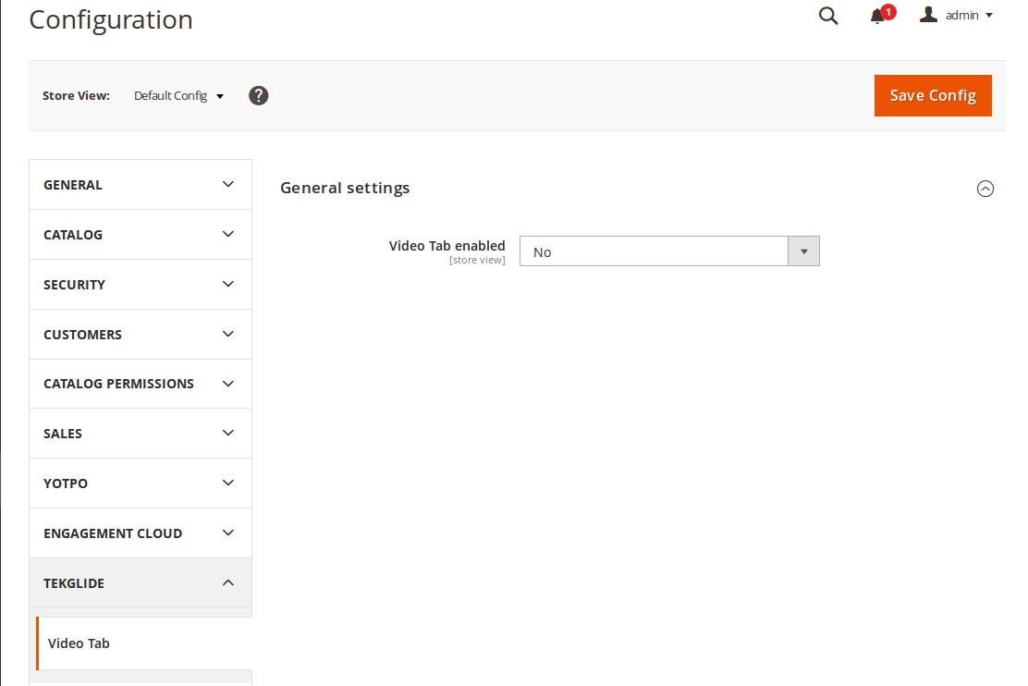

**1.**

* **General Settings**:
  + Choose **YES** to enable this module or **NO** to disable.
* **How to set video to a product**
  + From Magento Admin, Go to Catalog > Product section.

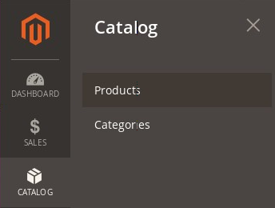

* Find the **Product** you want to add the video to and open it to edit.

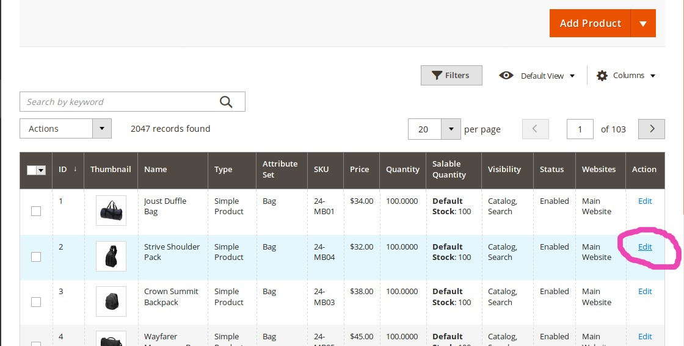

* Find the **Video tab,** you need to click it to add video to this product.

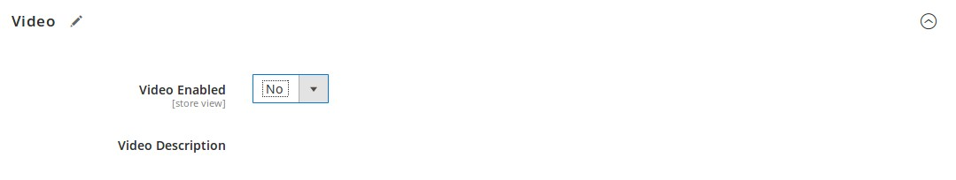

* **Video Enabled**: Choose **NO** to hide video to this product page (hide other text box related to this tab) or **YES** to display the video to this product page.

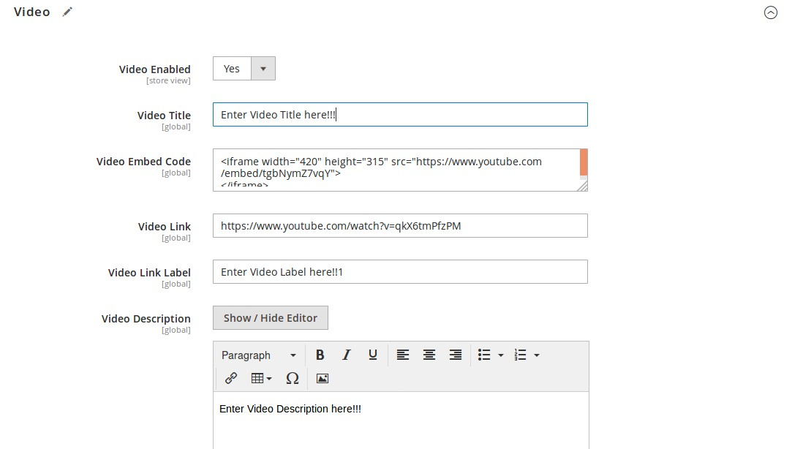

* **Video Title**: Enter video title here (optional).
* **Video Embed Code**: Enter video URL (must write URL in given format);

<iframe width="789" height="444" src="https://www.youtube.com/embed/nYh-n7EOtMA" frameborder="0" allow="accelerometer; autoplay; encrypted-media; gyroscope; picture-in-picture" allowfullscreen></iframe>

* **Video Link**: Enter Video Label here (optional).
* **Video Description**: Enter video description here (optional).
* After all, click on Save button to save data.

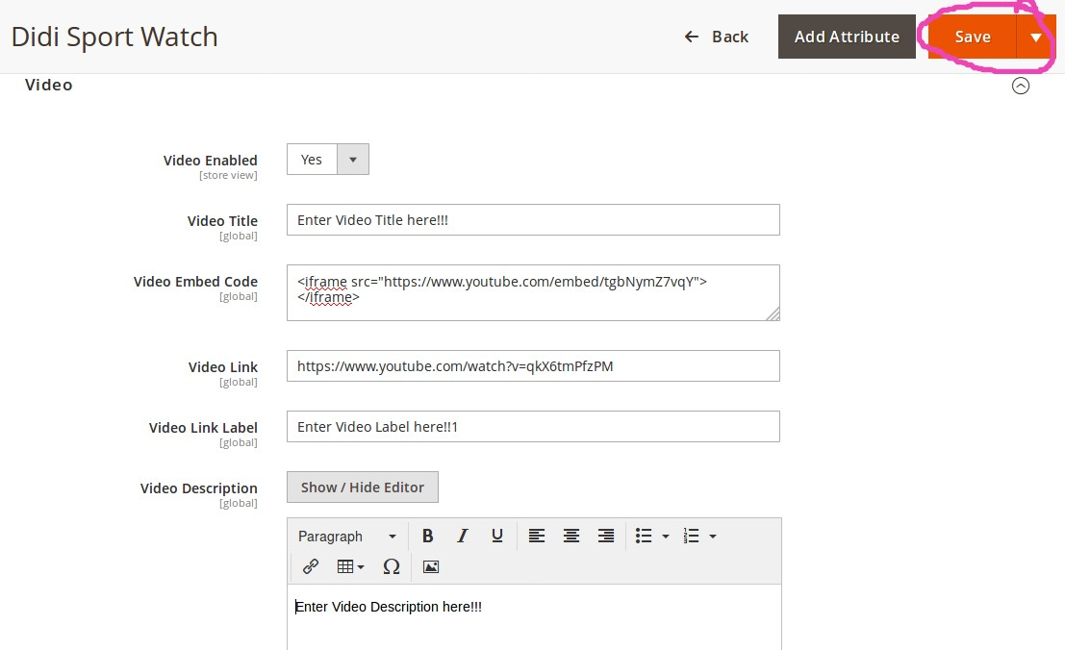

If product is saved successfully, following message will display.

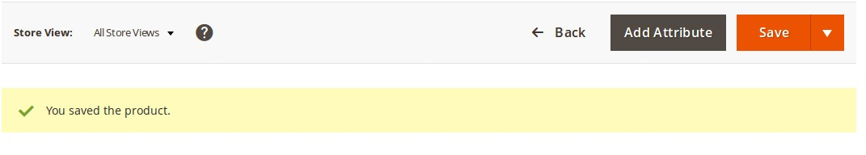

Now, go to website homepage and choose category and then click on video enabled product and see;

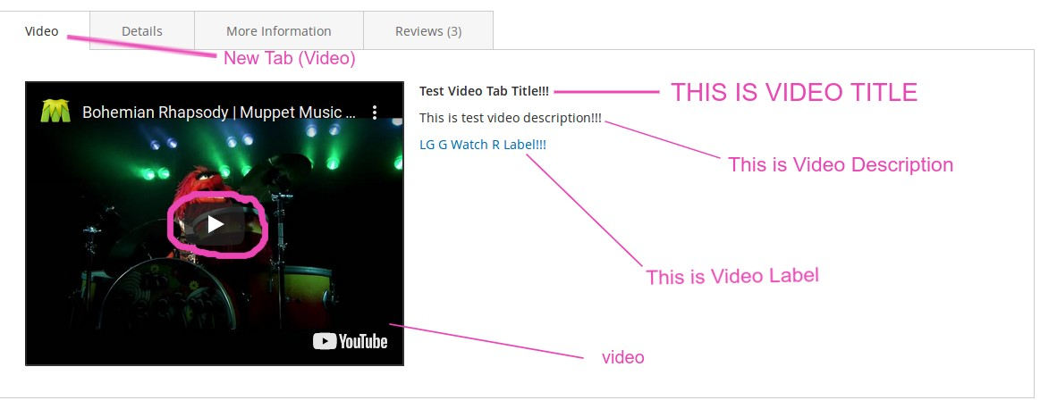

A new tab with name Video appear here. In Video tab, we can see

**Video**: custom video (Click on youtube clicker to play video)

**Video Title**: custom video title.

**Video Description**: custom video description.

**Video Label**: custom video label.